D D T & S W E E T S A N D S D E S T I N A T I O N S WELCOME YOU TO HAWAII 2022

The dates are: SEPTEMBER 10TH-16TH • 2022
We check out of the hotel on the 15th and arrive back to JFK on the 16th
We’ll be staying at the Luxurious SHERATON WAIKIKI, HAWAII•
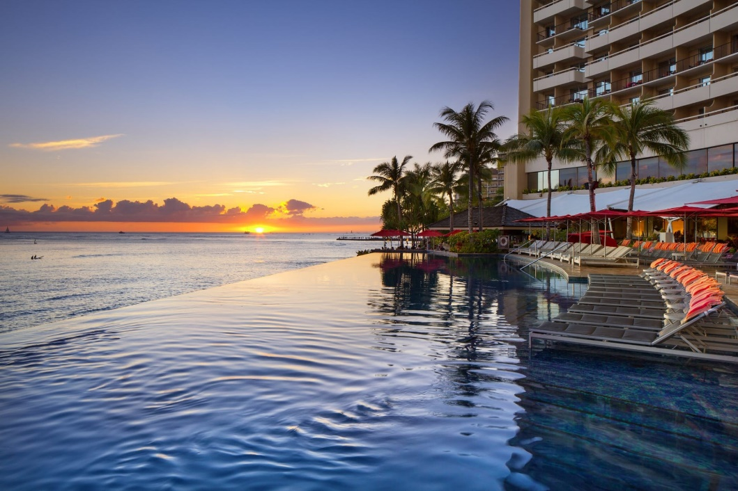

PRICES & ROOM OPTIONS:
All prices are based on Double Occupancy:
DOUBLE ROOM OCCUPANCY:
CITY VIEW: $1190
PARTIAL OCEAN VIEW: $1225
OCEAN VIEW: $1285

TRIPLE ROOM OCCUPANCY:
CITY VIEW: $1136
PARTIAL OCEAN VIEW: $1155 OCEAN VIEW: $ 1199
QUAD ROOM OCCUPANCY:
CITY VIEW: $1100
PARTIAL OCEAN VIEW: $1125 OCEAN VIEW: $ 1155

SINGLE ROOM OCCUPANCY:
CITY VIEW: $2115
PARTIAL OCEAN VIEW: $2170 OCEAN VIEW: $2295

Payment Plan:
Payment Plan for Double, Triple and Quad Occupancy Rooms (Please note final payment differences per room).
$200 deposit due July 1, 2021
$165 due 9/1/21, 11/1/21, 1/1/22, 3/1/22, 5/1/22 Final Payment is due July 1, 2022
Quad Final payment: 7/1/22: $75
Partial Ocean View ($1125)
Ocean View ($1155) Final payment: 7/1/22: $100 Final payment: 7/1/22: $130
****TRIPLE AND DOUBLE ROOM OCCUPANCY****
Triple and Quad Rooms are priced for double rooms with two beds. The hotel will include a third and fourth roll away bed.

Single:
City View ($2115) Final Payment: $315
Partial Ocean View ($2170) Final payment: $370
Ocean View ($2295) Final payment: $495
Payment Plan for Single Occupancy Rooms (Please note final payment
differences per room).
$300 deposit due July 1, 2021
$300 due 9/1/21, 11/1/21, 1/1/22, 3/1/22, 5/1/22 Final Payment is due July 1, 2022

****Guest Under 17 Years Old****
There is no hotel stay payment needed for children under 17 years old if no additional bed is needed but there will be a transportation fee added for children old enough to occupy a seat.
If an additional bed is needed, they will need to pay $750 for the roll away bed and fees. Payments: Zelle: sweetsandsdestinations@gmail.com
Cashapp: $mrstanyah
Fees, Refunds, Travel Insurance:
All refunds will incur a $100 non-refundable administrative charge on top of refund charges
Full refund minus administrative charge up to October 31, 2021
75% refund Minus admin charge Nov 1, 2021-Jan 31st, 2021
50% refund minus admin charge Feb 1-April 31st , 2022
25% refund minus admin charge May 1-July 31st, 2022
No refund after August 1, 2022
TRIP PROTECTION:
Travel Insurance (highly recommended) will be available for purchase separately thought Travel Guard or you can purchase travel insurance from your preferred vendor.
Mandatory registration form will be posted shortly
Including information on travel insurance (paid separately)

PLEASE NOTE: The payment schedule(s) noted above must be strictly followed in order to guarantee the package rates in effect when your deposit is made. Failure to follow the established payment schedule may result in changes/loss or increases to your package rate. Payment of deposit confirms your acceptance of this policy. Client agrees to be responsible for the layaway amount due at time of Cancellation.
All rates are effective today and subject to change until a deposit is received.
FLAMES: ***You AND YOUR ROOMMATE must keep up with the Layaway Plan in order to keep your room secured*** ALL PAYMENTS MUST BE MADE BY MONEY ORDER, BANK CHECK, ELECTRONIC BILL PAY OR ELECTRONIC CASH APPS ( ZELLE: sweetsandsdestinations@gmail.com) CASHAP: ($MRSTANYAH).
PLEASE DO NOT USE PAYPAL!! If you do, please add a 3% service fee each time you do. We prefer Cashap: ($mrstanyah), Zelle (sweetsandsdestinations@gmail.com) or Electronic Bill pay from your Bank. IF YOU WANT TO USE A CREDIT CARD, Please go to our website: www.Dancindougtravel.com and hit the payment link. WE DISCOURAGE THE USE OF PAYPAL!! To set up Electronic Bill Pay (Preferred method of payment), please use the DDT address above and designate Dancin' Doug Travel as the Payee, add your name as your account number with Hawaii2022 at the end e.g. ColonHawaii2022. LaTanya’s Contact information is latanya.sweetsands@gmail.com or (646) 465-2898.
**NO PERSONAL CHECKS ACCEPTED** They will be Returned.

RESERVATION FORMS: EACH person must fill out a registration form in order to be secured in their room. Just go to the DDT Website: http://www.dancindougtravel.com/vacations and fill out the online Registration form. The Trip has been uploaded, so fill in the type of room you want under “ANY SPECIAL NEEDS BOX”,

CANCELLATION POLICY:
300 days or more, prior to scheduled group arrival date, no PENALTY will be assessed. 300-240 days prior to/up to group arrival date of trip: There will be a 25% Penalty of Total cost of room. 240-180 day prior to/up to group arrival date: There will be a 50% Penalty of Total cost of room. 180-120 days prior to/up to group arrival date: There will be a 100% Penalty (TOTAL COST OF ROOM). THERE’S A STANDARD DDT ADMINISTRATIVE FEE OF $100 ADDED ONTO ALL HOTEL FEES AND CANCELLATIONS.
Flights are not Included TRAVEL INSURANCE: Not Choosing whether or not you want Travel Insurance will result in an incomplete application. You will need to select the Policy that you want and make payment. Travel Insurance is not in effect until it's paid for. TRIP PROTECTION: Basic Trip Protection will be available. Travel Guard Product Comparison. You can select your own policy/coverage by combining/copying the link here: https://buy.travelguard.com/tgi2/pct/default.aspx? Just put in all of your information and select the plan you want. The info will be sent to us.
We ALWAYS HIGHLY recommend that everyone purchase Trip Protection, even if it’s not through us, to protect you from the unexpected. For additional information please contact: LaTanya Harris at latanya.sweetsandsdestinations@gmail.com
Or (646) 465-2898
OUR MOTTO IS: "WE START WITH PRAYER--WE FINISH WITH PRAYER--AND WE HAVE A WHOLE LOT OF FUN IN BETWEEN!" WE LIKE TO KEEP IT DRAMA FREE -- SO LEAVE POOKIE AND SHANAYNAY AT HOME, THEY AINT INVITED!!!
Come to DDT as Friends--Leave as Family! We're Building Something Special! ME FOR YOU. YOU FOR ME.
ITS A LOVE THANG!!
DOUG/LATANYA

