
DDT BALI
MAY 24-31, 2025
DDT IS TAKING YOU TO ANOTHER EXOTIC VENUE
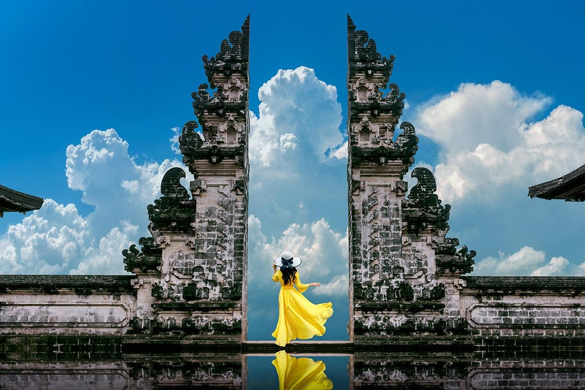
Join DDT as we explore the Amazing Country of BALI. You asked for it.
Here it is!!

DDT Bali Tour 2025
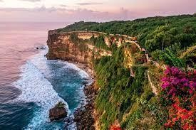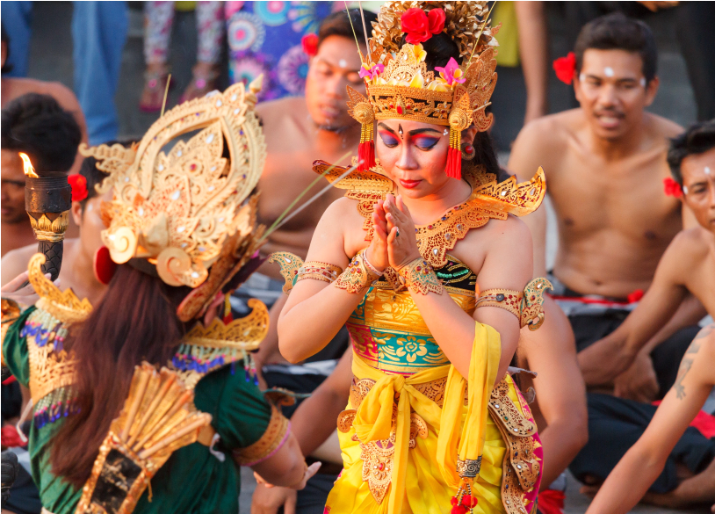
Our Detailed Itinerary:

DAY 1) Depart USA

DAY 2) Arrive Bali
Upon clearing Customs and Immigration, we’ll meet our local tour guide. Our guide will present us with a welcome packet including all necessary documentation and vouchers and all contact information of our guide and local offices. Then will transfer us to our resort hotel. We’ll have free time to rest, relax and acclimate to our new time zone.

DAY 3: . Bali Kuta (Breakfast, Special Welcome Dinner)
This morning we’ll enjoy our breakfast at the hotel and will have some leisure time to relax. Then, experience an evening of Kechak Dance at a cliff top temple followed by a barbeque seafood dinner under the stars. In the late afternoon we’ll be taken to the location of the famous cliff hanging temple at Uluwatu. Perched on the edge of a steep cliff, the temple sits 70 meters above the crashing waves of the Indian Ocean. The temple is inhabited by a large number of monkeys, many of whom can be found roaming the pathways.
As the sun sets over the glittering ocean, we’ll watch a dramatic Kechak Dance or Ramayana Monkey Chant performance at the temple. Wearing traditional checked cloth around their waists, the male dancers chant in unison while depicting a battle from the Ramayana. After the performance drive to one of the beautiful beaches in Jimbaran for a barbeque seafood dinner in a beach restaurant. Feast on a succulent seafood platter including prawns, grilled fish, squid and clams. Try some 'kangkung', also known as Indonesian water spinach, and add some heat in the form of sambal, the spicy Indonesian sauce.

DAY 4: Bali Kuta (Breakfast)
Today is a free-day at leisure. You can relax, be pampered, eat delicious food and soak up the sun. OR join Optional Tour to Water Palace with Lunch: $90/person
Tirta Gangga Water Palace: Tirta Gangga is a former royal palace in eastern Bali. It is noted for the Karangasem royal water palace, bathing pools and its Patirthan temple. The one hectare complex was built in 1946 by the late King of Karangsem but was destroyed almost entirely by the eruption of nearby Mount Agung in 1963.
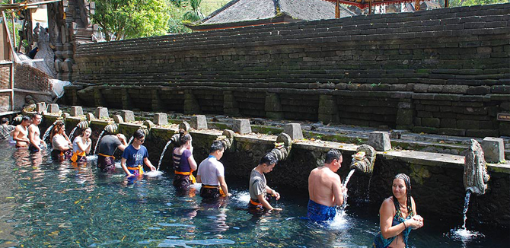

DAY 5: Bali Kuta - Ubud (Breakfast)
Today after enjoying breakfast, we’ll drive to Ubud (about 1 hour). On the way to Ubud, we’ll visit the Coffee Factory to have a coffee break and visit UC Silver store. Ubud still reflects the unique Balinese way of life as well as emanating a whole lot of charm and a low-key vibe that is irresistible. After check-in at Hotel, the rest of the day is on our own leisure.

DAY 6: . Ubud (Breakfast, Lunch)
Today is a full day tour. Head east and discover rice terraces, sleepy villages, ancient temples, and towering volcanos. In the morning, meet our guide and driver and set off towards the east of the island. Stop in the quaint and very well-kept countryside village of Penglipuran. Walk along the narrow streets to see the traditional Balinese houses with their typical entrance gates and unique architectural traditions. Continue to the western slopes of Mount Agung where Besakih, the Mother Temple is located. This stunning complex of temples is the most sacred in Bali and is visited at least once a year by all Balinese Hindus for special ceremonies. Lunch is taken in a local restaurant with views of rice fields and the backdrop of Mount Agung. After lunch take a walk-through Sidemen, a rural area known for its beautiful landscapes and traditional weaving. Visit a fruit plantation to see the unusual salak fruit also called snakeskin fruit. The last stop is at Klungkung to visit the former Royal Courts of Justice known as Kerta Gosa. The highlight here is the unique and elaborately decorated ceiling painting depicting the battle of good versus evil.
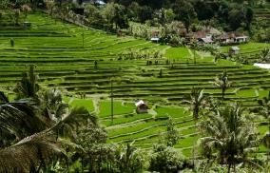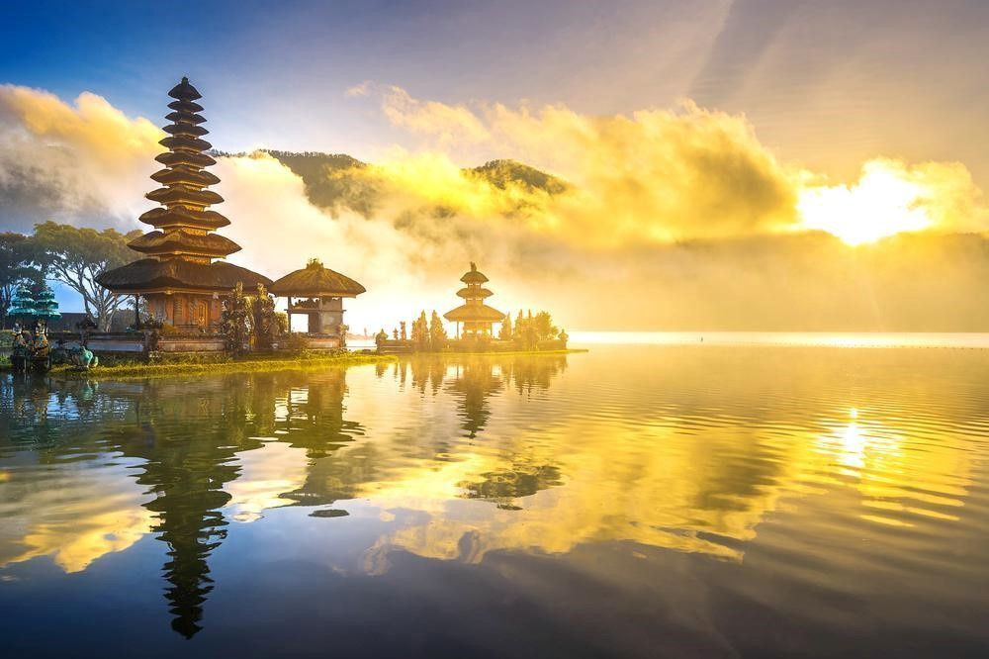
Day 7: Ubud (Breakfast) Today is a free day at leisure.
OR join Optional Tour to Enhancing Ubud with Lunch: $100/person

Tirta Empul Temple
Visit the Tirta Empul Temple, built in 960 B.C. during the reign of Warmadewa Dynasty. A temple has been built around natural springs and special bathing pools. The unstoppable water flow is believed to be able to cure any kind of disease. Balinese believe that by bathing in the holy springs, their spirits will be cleansed and their physical illnesses will be cured.
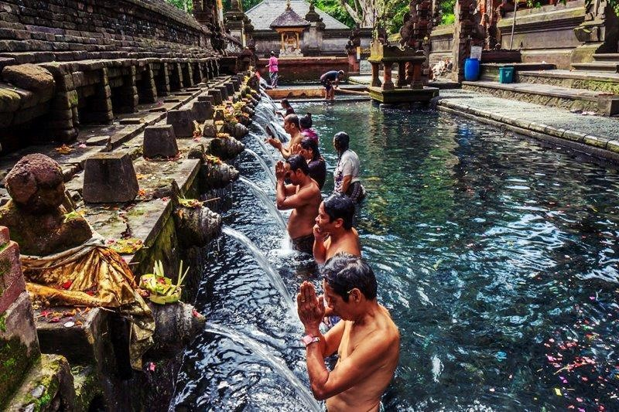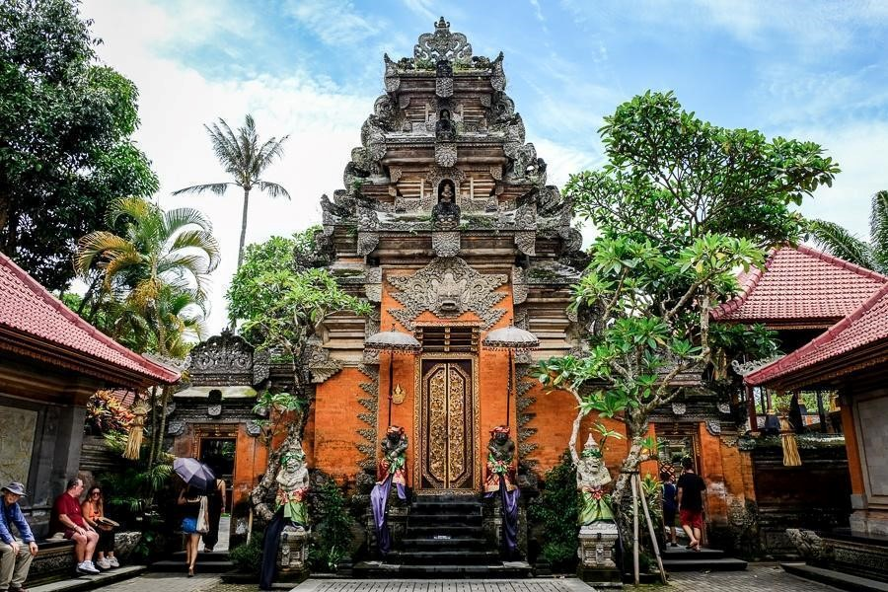

Ubud Market
Set amidst emerald green rice paddies and steep ravines in the stunning central Balinese foothills, Ubud was originally an important source of medicinal herbs and plants. Visit Ubud art market located in the center of the town just opposite the Palace, stroll in the market and through the streets - the only way to really appreciate the special atmosphere one will find here.

Ubud Palace
The Ubud Palace, officially Puri Saren Agung, is a historical building complex situated in Ubud, Gianyar Regency of Bali, Indonesia. The palace was the official residence of the royal family of Ubud. It was on his travels that Rsi Markandya received a divine revelation that in Bali he was to bury five precious metals on a mountain slope where the mother temple of Besakih now stands today.

DAY 8: . Bali departure (Breakfast)
Time to say goodbye. Your amazing Bali tour ends today. Our tour guide will transfer us to the airport (DPS) and say goodbye to us at the airport. Next stop--home sweet home.

Hotels:

Bintang Bali Resort (5*), a beachfront property in Kuta Beach
Address: Jl. Kartika Plaza, Kuta, Kec. Kuta, Kabupaten Badung, Bali 80361, Indonesia
Phone: +62 361 753292

Sthala Ubud by Marriott (5*)
Address: Jalan A.A Gede Rai, Jl. Raya Mawang Kelod, Lodtunduh, Ubud, Bali 80571, Indonesia Phone: +62 361 3018700

EXCLUSION:
AIRFARE IS NOT INCLUDED.

Passports & Visas: Passengers are required to hold a passport valid for six months beyond travel dates and are responsible to obtain visa(s) as needed. US citizens require a passport valid for six months beyond travel dates.
Group Harmony: To ensure the desired group synergy, DDT reserves the right to accept, reject or expel any individual who is deemed disruptive or incompatible with the interests of the group, including, but not limited to, individuals who are intoxicated and/or under the influence of drugs leading to a negative experience for the remainder of the group. Expenses, including cancellation fees and/or costs for alternate travel plans or to return home, will necessarily be borne by the passenger. All unused services are non-refundable.

PRICE: $1800 DBL/TPL AND $2,400 FOR A SINGLE

DDT LAYAWAY PLAN:

MARCH 1, 2024: $300 dbl/tpl AND $400 for Single.
MAY 1, 2024: $300 dbl/tpl AND $400 for Single.
JULY 1, 2024: $300 dbl/tpl AND $400 for Single.
SEPTEMBER 1, 2024: $300 dbl/tpl AND $400 for Single.
NOVEMBER 1, 2024: $300 dbl/tpl AND $400 for Single.
JANUARY 15, 2025: $300 dbl/tpl AND $400 for Single. FINAL PAY
You HAVE to keep up with the Layaway Plan or your room and deposit will be forfeited.
YOU DON’T HAVE TO WAIT FOR THE DEPOSIT DATE--GET YOUR PAYMENT IN EARLY TO SECURE YOUR ROOM!
PLEASE TRY NOT TO USE PAYPAL!!
If you do, please add a 3% service fee each time you do--or we will add on your final bill.
We prefer Cashap: $DDTCSITRAVEL, Zelle (678-602-9813) or Electronic Bill pay from your Bank.
PLEASE NOTE: The payment schedule(s) noted above must be strictly followed in order to guarantee the package rates in effect when your deposit is made.
Failure to follow the established payment schedule may result in changes/loss of deposit/payments or increases to your package rate. Payment of deposit confirms your acceptance of this policy. Client agrees to be responsible for the layaway amount due at time of Cancellation.
All rates are effective today and subject to change until a deposit is received.
FLAMES: You AND YOUR ROOMMATE must keep up with the Layaway Plan in order to keep your room secured.

ALL PAYMENTS MUST BE MADE BY MONEY ORDER, BANK CHECK, ELECTRONIC BILL PAY, ZELLE: (678-602-9813) CASHAP: ($DDTCSITRAVEL).
PLEASE MAIL PAYMENTS TO: DANCIN DOUG TRAVEL, PO BOX 82386, CONYERS, GA 30013.

IF YOU WANT TO USE A CREDIT CARD, Please go to our website: www.Dancindougtravel.com and hit the payment link. WE DISCOURAGE THE USE OF PAYPAL!! A 3% charge will be added onto your bill at the conclusion if you use Paypal.

To set up Electronic Bill Pay please use the DDT address above and designate Dancin' Doug Travel as the Payee, add your name as your account number with GHANA at the end e.g. ColonGHANA. Our phone number is (678) 602-9813.

NO PERSONAL CHECKS ACCEPTED. They will be Returned.

CANCELLATION POLICY:

300 days or more, prior to scheduled group arrival date, no PENALTY will be assessed.
300-240 days prior to/up to group arrival date of trip: There will be a 25% Penalty of Total cost of room.
240-180 day prior to/up to group arrival date: There will be a 50% Penalty of Total cost of room.
180-150 days prior to/up to group arrival date: There will be a 75% Penalty of Total cost of room
150-120 days prior to/up to group arrival date: There will be a 100% Penalty (TOTAL COST OF ROOM).

THERE’S A STANDARD DDT ADMINISTRATIVE FEE OF $200 ADDED ONTO ALL HOTEL FEES AND CANCELLATIONS.

+++++++++++++++++++++++++++++++++++++++++++++++++

TRIP PROTECTION: Updated as of 9/2022
There are several plans to choose from. Although we can’t force you, we HIIGHLY recommend that you purchase Travel Insurance—even if it’s not from us.
Not Choosing whether or not you want Travel Insurance will result in an incomplete application. You will need to DECLINE or select the Policy that you want and make payment.
Travel Insurance is not in effect until it's paid for. Failure to select and pay for a policy will be determined as a declination so please select one. Basic Trip Protection will be available.



TRAVEL INSURANCE

UPDATED:

We’ve changed our travel insurance company. We now are with IMGlobal (International Medical Global) Travel Insurance. Please click the link (press the CTRL+click link) below to select your plan.

LINK TO WEBSITE >> IMGlobal Travel Insurance

